ECE 4438 Advanced Digital Image Processing

Assignment 1

Professor: Yimin Yang

JD. Herlehy, Jacky Li

## MLP Using SIFT Feature Extraction Method Setup and Parameters

Using the SIFT feature extraction method, 50 of the strongest points were selected from grayscale, histogram-equalized images. These 50 points were then used to create the feature matrix and formatted to be accepted by the featureInputLayer. The input dataset was subsequently divided into training and testing datasets (90% and 10% respectively), with labels attached to each.

With the dataset fully formatted, the structure of the MLP can be created. The options for the MLP were chosen as follows:

options = trainingOptions('sgdm', ...

'MaxEpochs',300,...

'InitialLearnRate',2e-3, ...

'Verbose',false, ...

'Plots','training-progress');

Based on experimental results, a learning rate of 2e-3 was found to be optimal for testing accuracy and computational time, achieving ~100% training accuracy. The number of epochs was selected to ensure that the model reached ~100% training accuracy with the chosen learning rate.

The layers were chosen based on experimental results as well. Three fully connected (FC) layers with a batch normalization layer preceding each FC layer yielded the highest training accuracy. Additionally, adding a ReLU layer before the final classification layer ensured training accuracy remained above 50%. This is theorized to activate the final classification layer, but further testing is required.

layers = [featureInputLayer(size(Data,2))

batchNormalizationLayer

fullyConnectedLayer(32)

batchNormalizationLayer

fullyConnectedLayer(8)

batchNormalizationLayer

fullyConnectedLayer(2)

batchNormalizationLayer

reluLayer

classificationLayer

];

## MLP Using SIFT Feature Extraction Training and Testing Results

In Figure 1, this graph displays the training accuracy and loss function of the model in Section 1.1. The model consistently achieves ~100% training accuracy within the allocated number of epochs. Additionally, the loss function descends below -2, indicating that the model's predictions, at least within the training dataset, are accurate.

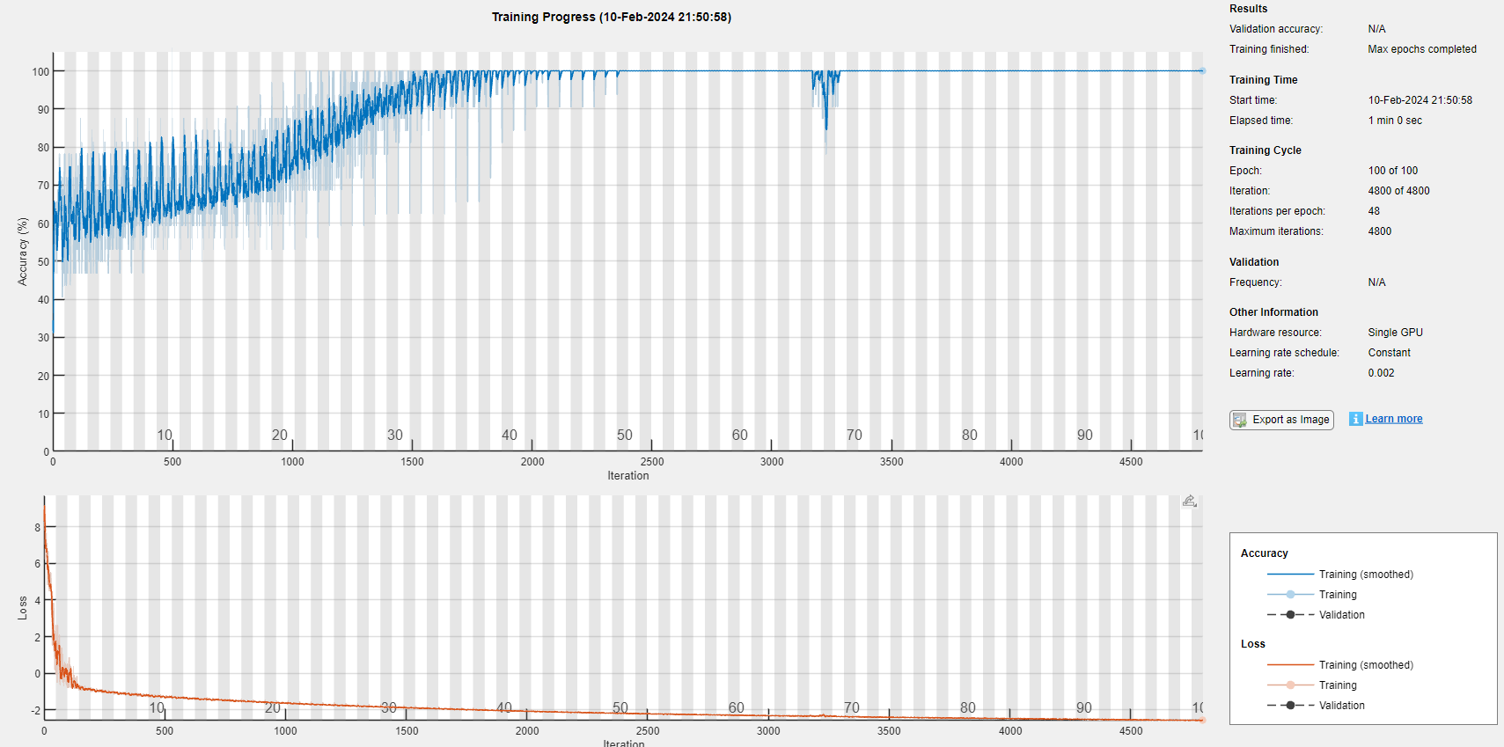

Figure 1 MLP Training using SIFT Feature Extraction

The test accuracy using the SIFT model exhibits a significant decrease in accuracy (Figure 2) compared to the high training accuracy. This is likely due to the introduction of completely new images that the model has not been trained on.

Figure 2 Test Accuracy Using MLP with SIFT Feature Extraction

## 2.1 MLP Using Raw Images, Setup and Parameters

The only changes that need to be done to transfer the SIFT method to the raw images method is to change the input matrices, and change the first input layer of the MLP. The new layer structure is below:

layersRaw = [

imageInputLayer([524 524 3])...

batchNormalizationLayer ...

fullyConnectedLayer(32) ...

batchNormalizationLayer ...

fullyConnectedLayer(8) ...

batchNormalizationLayer ...

fullyConnectedLayer(2) ...

batchNormalizationLayer ...

reluLayer ...

classificationLayer];

Using the same MLP parameters as 1.1, the results in 2.2 are generated.

## 2.2 MLP Using Raw Images, Results

In Figure 3, the training result of using raw images as input is lower than the training accuracy achieved with the SIFT feature extraction method as input. However, as shown in Figure 4, the testing accuracy is higher than that achieved with the SIFT method (Figure 2). This inconsistency could be attributed to the fact that when using the SIFT feature method, significantly fewer points are used to feed into the input layer compared to using the raw 524x524 images. This compression of information allows the SIFT model to train faster but at a lower testing accuracy, while training and testing with full pictures are slower to train but more accurate during testing.

Figure 3 MLP Training using Raw Image Input

Figure 4 Test Accuracy Using MLP with Raw Image Input